**Jenkins Architecture**

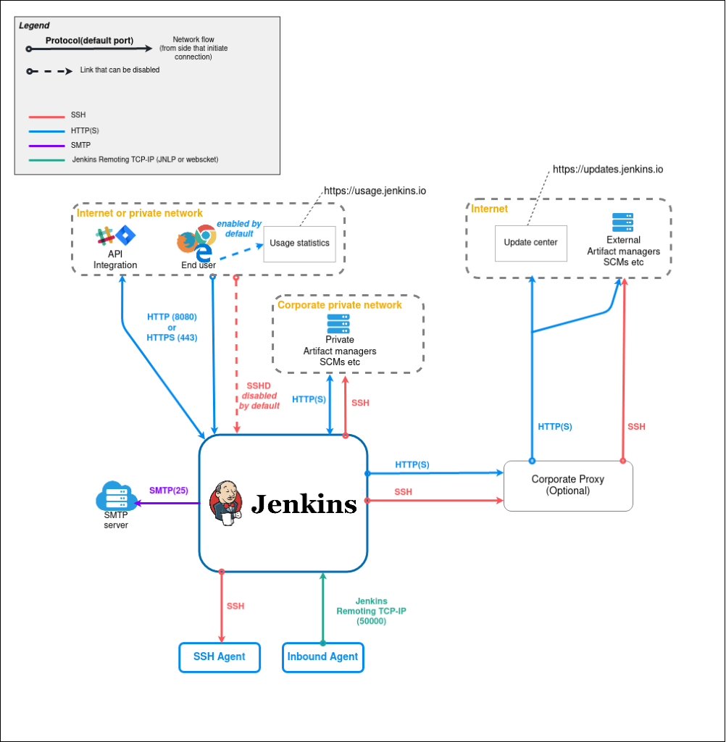

Jenkins Architecture

Jenkins is commonly used for the following.

Continuous Integration for application and infrastructure code.

Continuously deliver pipeline to deploy the application to different environments using Jenkins pipeline as code.

Infrastructure component deployment and management.

Run batch operations using Jenkins jobs.

Run ad-hoc operations like backups, cleanups, remote script execution, event triggers, etc.

Jenkins Pipeline Integration

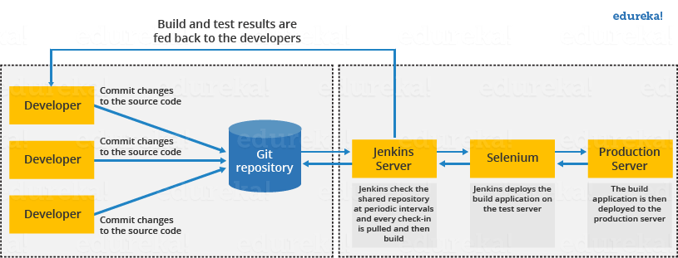

  Jenkins Master

Jenkins Master (Server) 
jobs 
users 
Plugins 
Credentials 
Nodes/Clouds 
Global Configs 
Jenkins Static Slaves 
(Nodes) 
SSH (22) 
JNLP(50000) 
Cloud API 
JNLP (50000) 
Linux Slave 
Linux Slave 
Linux Slave 
Linux Slave 
Jenkins Dynamic Slaves 
(Clouds) 
docker 
o 
Kubernetes 
Engine 
Kubernetes 
a 
Amazon ECS 

* Plugin Management in Jenkins

Updates 
Available plugins 
Installed plugins 
Advanced settings 
Plugins 
Q blue ocean 
Install 
Name 
Blue Ocean l. 27.3 
External Site'TooI Integrations 
31ueOcean Aggregator 
user Interface 
Display URL for Blue Ocean 2.4.1 
This plugin generates BlueOcean specific URLs for the Display URL plugin. 
personalization for Blue Ocean 1.27.3 
External Site'TooI Integrations user Interface 
Blue Ocean Personalization 
Bitbucket Pipeline for Blue Ocean 1.27.3 
BlueOcean Bitbucket pipeline creator 
Released 
1 day 2 hr ago 
2 yr 1 mo ago 
1 day 2 hr ago 
I day 2 hr ago 
Install without restart 
Download now and install after restart 
update information obtained: 1 hr 18 min ago 
Check now 

**Docker Installation for Jenkins**

**Docker Installation Setup for Ubuntu 22**

*# Add Docker's official GPG key:*   
sudo apt-get update   
sudo apt-get install ca-certificates curl gnupg   
sudo install -m **0755** -d /etc/apt/keyrings   
curl -fsSL https://download.docker.com/linux/ubuntu/gpg **|** sudo gpg --dearmor -o /etc/apt/keyrings/docker.gpg   
sudo chmod a+r /etc/apt/keyrings/docker.gpg   
   
*# Add the repository to Apt sources:*   
echo \   
  "deb [arch=**$(**dpkg --print-architecture**)** signed-by=/etc/apt/keyrings/docker.gpg] https://download.docker.com/linux/ubuntu \   
  **$(**. /etc/os-release **&&** echo "$VERSION_CODENAME"**)** stable" **|** \   
  sudo tee /etc/apt/sources.list.d/docker.list > /dev/null   
sudo apt-get update

sudo service docker stop

sudo service docker start

**Add jenkins user to Docker group**   
**sudo usermod -a -G docker jenkins**   
   
**Restart Jenkins service**   
**sudo service jenkins restart**   
   
**Reload system daemon files** 

sudo systemctl daemon-reload   
   
Restart Docker service as well

Kubectl Installation

***How to install Kubectl in Ubuntu instance***

**Download keys from google website** 

curl -s <https://packages.cloud.google.com/apt/doc/apt-key.gpg> | sudo apt-key add -

**Create the below file** 

sudo touch /etc/apt/sources.list.d/kubernetes.list 

echo "deb <http://apt.kubernetes.io/> kubernetes-xenial main" | sudo tee -a /etc/apt/sources.list.d/kubernetes.list

**Update package manager** 

sudo apt-get update

**Install** 

sudo apt-get install -y kubectl

**Verify if kubectl got installed**

kubectl version --client